1. Setup VPC Transist gateway.

**Now go to Transist gateway attachments and create 4 attachments for 4 vpc.**

**Now launch 4 ec2 instances in 4 vpc and login to public ec2 and try to ping to vpc1 ec2 using private ip.**

**Connectivity is not available because we haven't mentioned where the traffic should be redirected**

**Now go to route tables of 4 vpc and add all the cidr range in routes with transit gateway atatchment.**

**Create internet gate ways for 4 vpc and edit 4 vpc routes and attach internet gateways**

**once done then try to ping again and this time it will work.**

2) Setup VPC End Point.

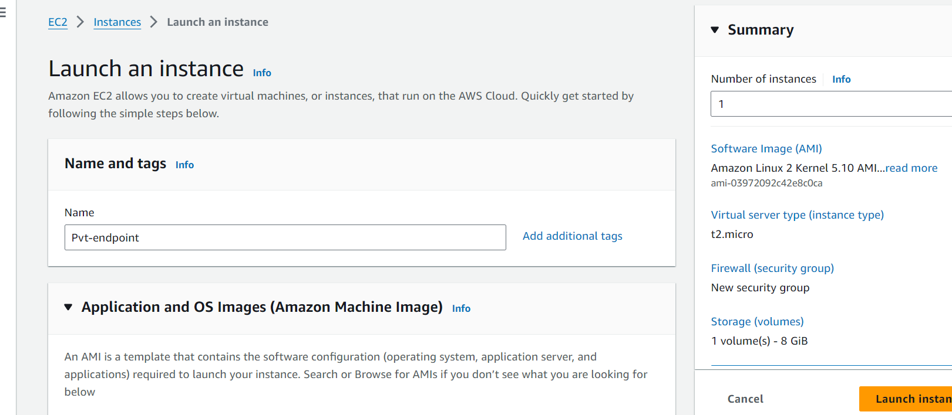

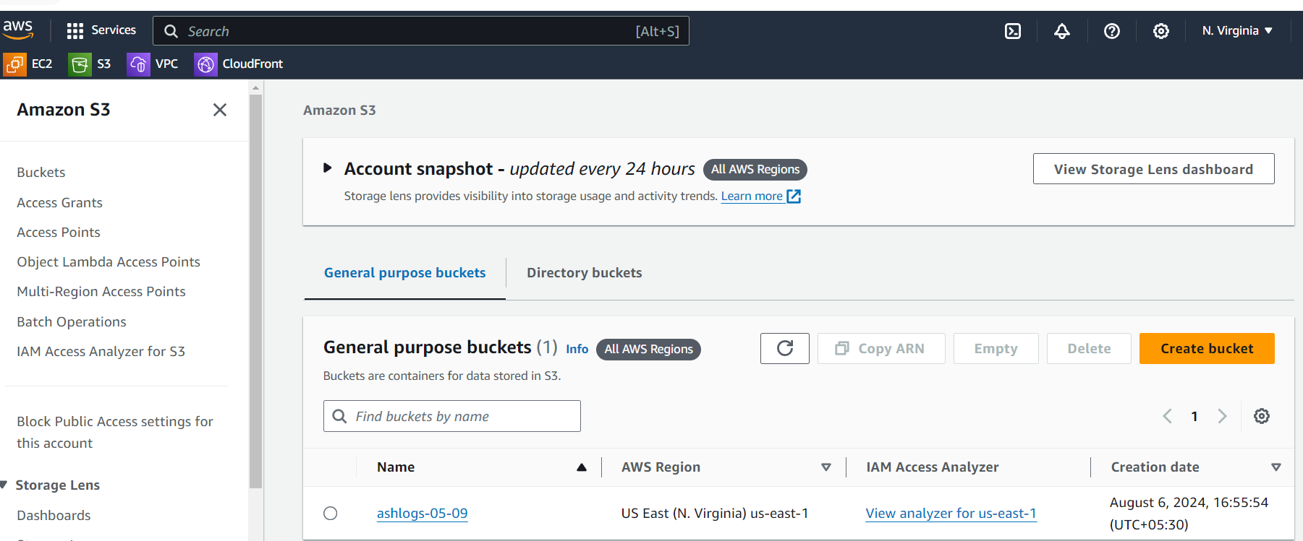

Login to public server and try to connect pvt instances as bastion

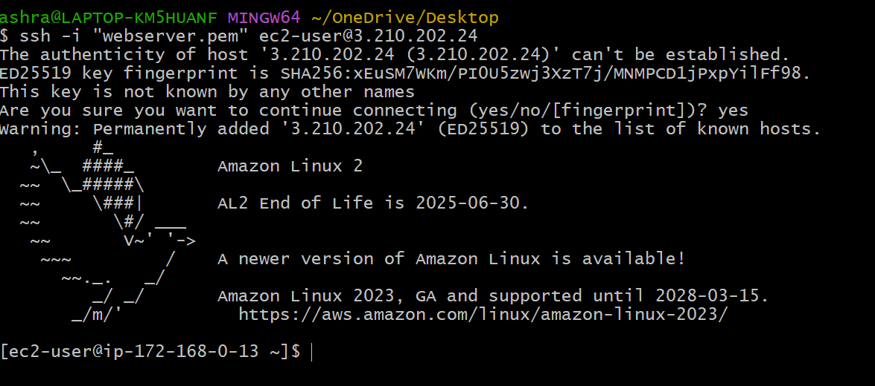

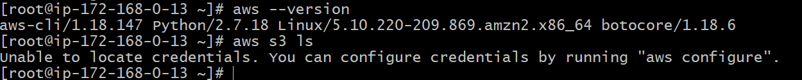

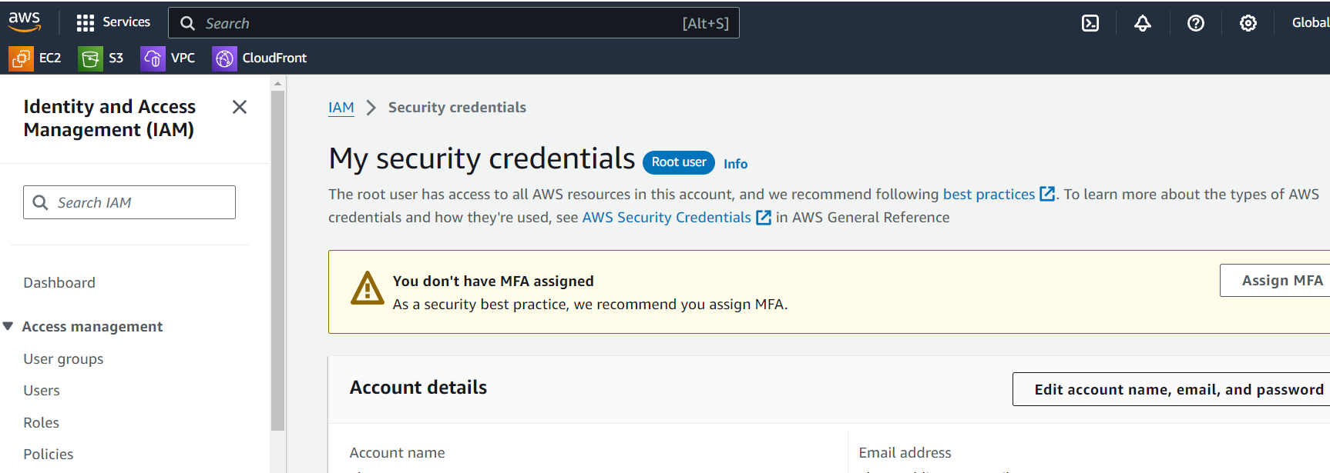

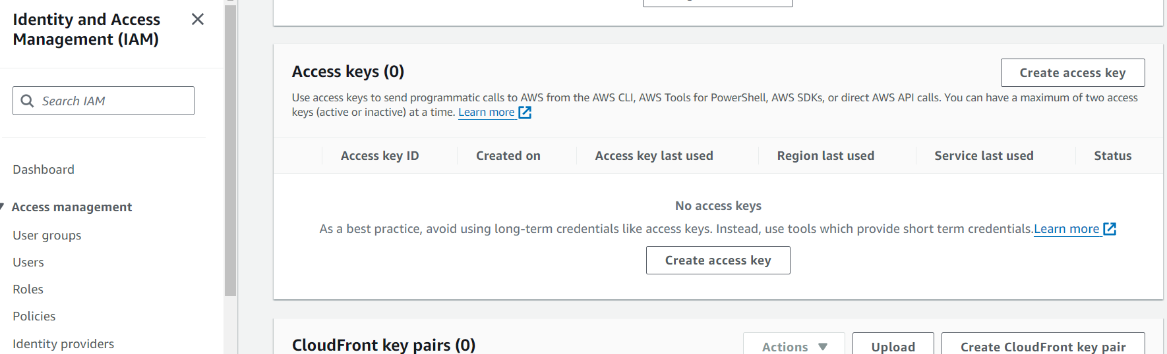

Connect to pvt instances as bastion

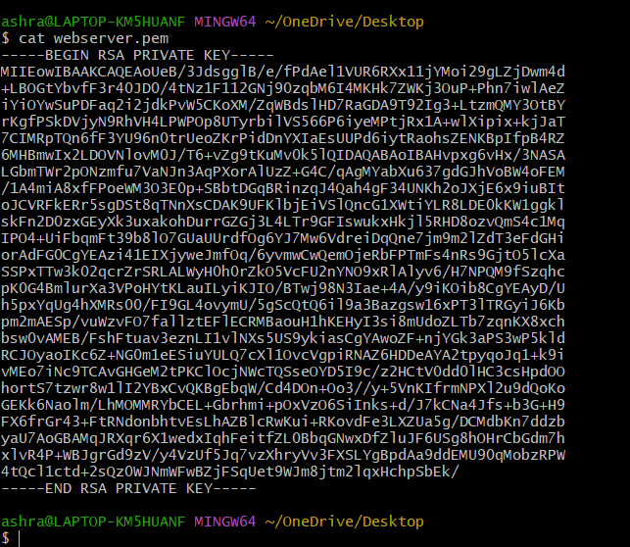

**Try to use pub ec2 as bastion and connect to private and execute**

**"aws s3 ls" --> this command will not work because of no internet access.**

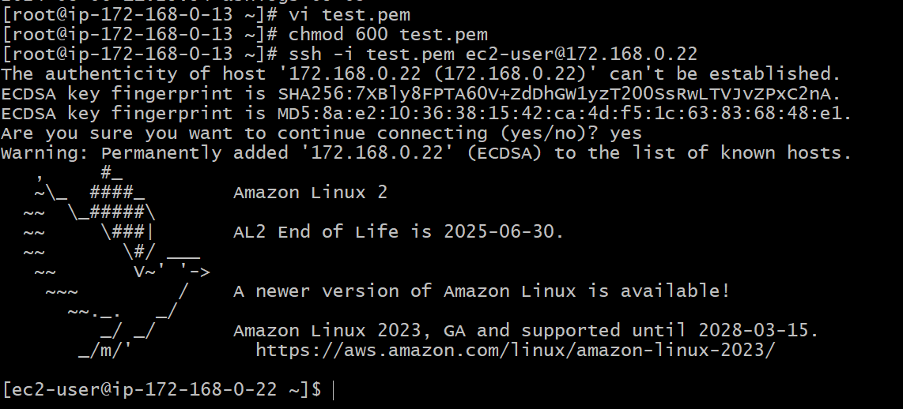

**Now go to vpc endpoint .**

**Create on endpoint,search for s3 and use s3 endpoint**

**category "aws services"**

**end point url "com.amazonaws.us-east-1.s3" type "gateway"**

